Helsinki University of Technology
Espoo, Finland

Content Management Framework

Architectural Overview

Project | IPMAN
Author | A. Mednonogov
Version | CMF-AO-1.00
Date | 9-May-2000

1 Introduction

The idea of Content Management Framework (CMF) is to produce a platform suitable for provisioning of personal business content into the Internet by content supplier, which can be easily accessed by content user. In this scheme, both entities are connected through CMF-enabled content provider that acts as an intermediary between supplier and user.

The structure of the framework is undermined by user practical needs in his everyday life. CMF shall make it easy for content supplier to satisfy these needs ad-hoc. The framework architecture is dictated by concrete scenarios of its usage (i.e. use cases) and not vice versa. Hence, it is proposed that during the first stage of the project a multitude of possible use cases is carefully examined and visually demonstrated by implementing a "black-box" version of CMF ("black-box" means that at this stage the internal structure of CMF is not known in detail, but its external functionality is known, as defined by use cases). Based on results of the first stage, a detailed framework architecture is designed and implemented. We take into account heterogeneity of user and supplier profiles and mass-oriented nature of content provisioning. Moreover, we are mainly focused on use cases for nomadic users and that exploit either wireless access to the Internet or WAP technology.

This framework is not expected to address: (1) news services personalization and (2) sophisticated Internet-based document retrieval engines, as it is evident that e.g. WAP technology will be unable to compete with the Internet in these areas. Moreover, both areas have been a subject of extensive research for the past few years, with all major concepts and algorithms already available.

Probably the most concise definition of CMF would claim that it implements a version of largely distributed and highly intelligent wide-scale retrieval engine with very compact user interface which would allow smart supply and navigation of service content, keeping in mind its potential for practical (and in most cases immediate) utilization, as opposed to traditional document search and navigation for academic or educational purposes. In this way, an attempt is made to introduce more real content to global mobile networks.
2 CMF High-Level Architecture

The high-level architecture of CMF is shown in Fig. 1. Content provider stores both user and supplier profiles to facilitate content personalization. It also stores set of preferred user agents, or delegates, to which the responsibilities for performing actions are delegated by user. User may choose the most suitable implementations among existing alternatives that best satisfy his needs. In the similar fashion, content suppliers interact with CMF core through a set of selected supplier agents. Important to notice that user agents are WAP-oriented while supplier agents are PC-oriented. Agents of both parties interact with each other by means of transaction processor which makes use of the database stored in a special format. Key issues are: (1) to provide a framework for agents design; (2) define the dynamically extendable format of database; and (3) standardize API for entities interaction.

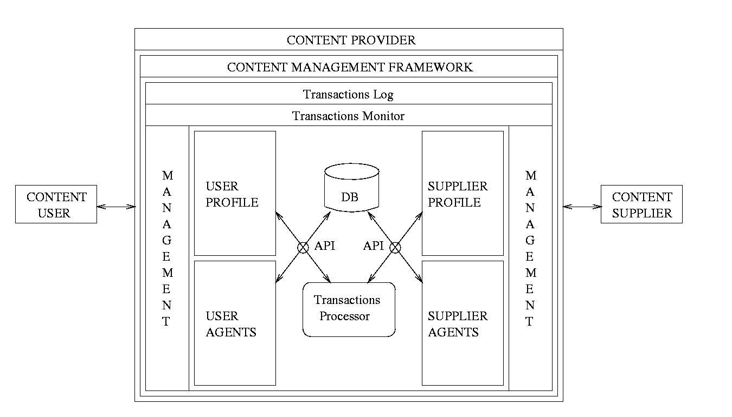Figure 1. Content Management Framework Architecture

3 CMF Project Mind Map

The mind map for CMF project is presented in Figure 2.
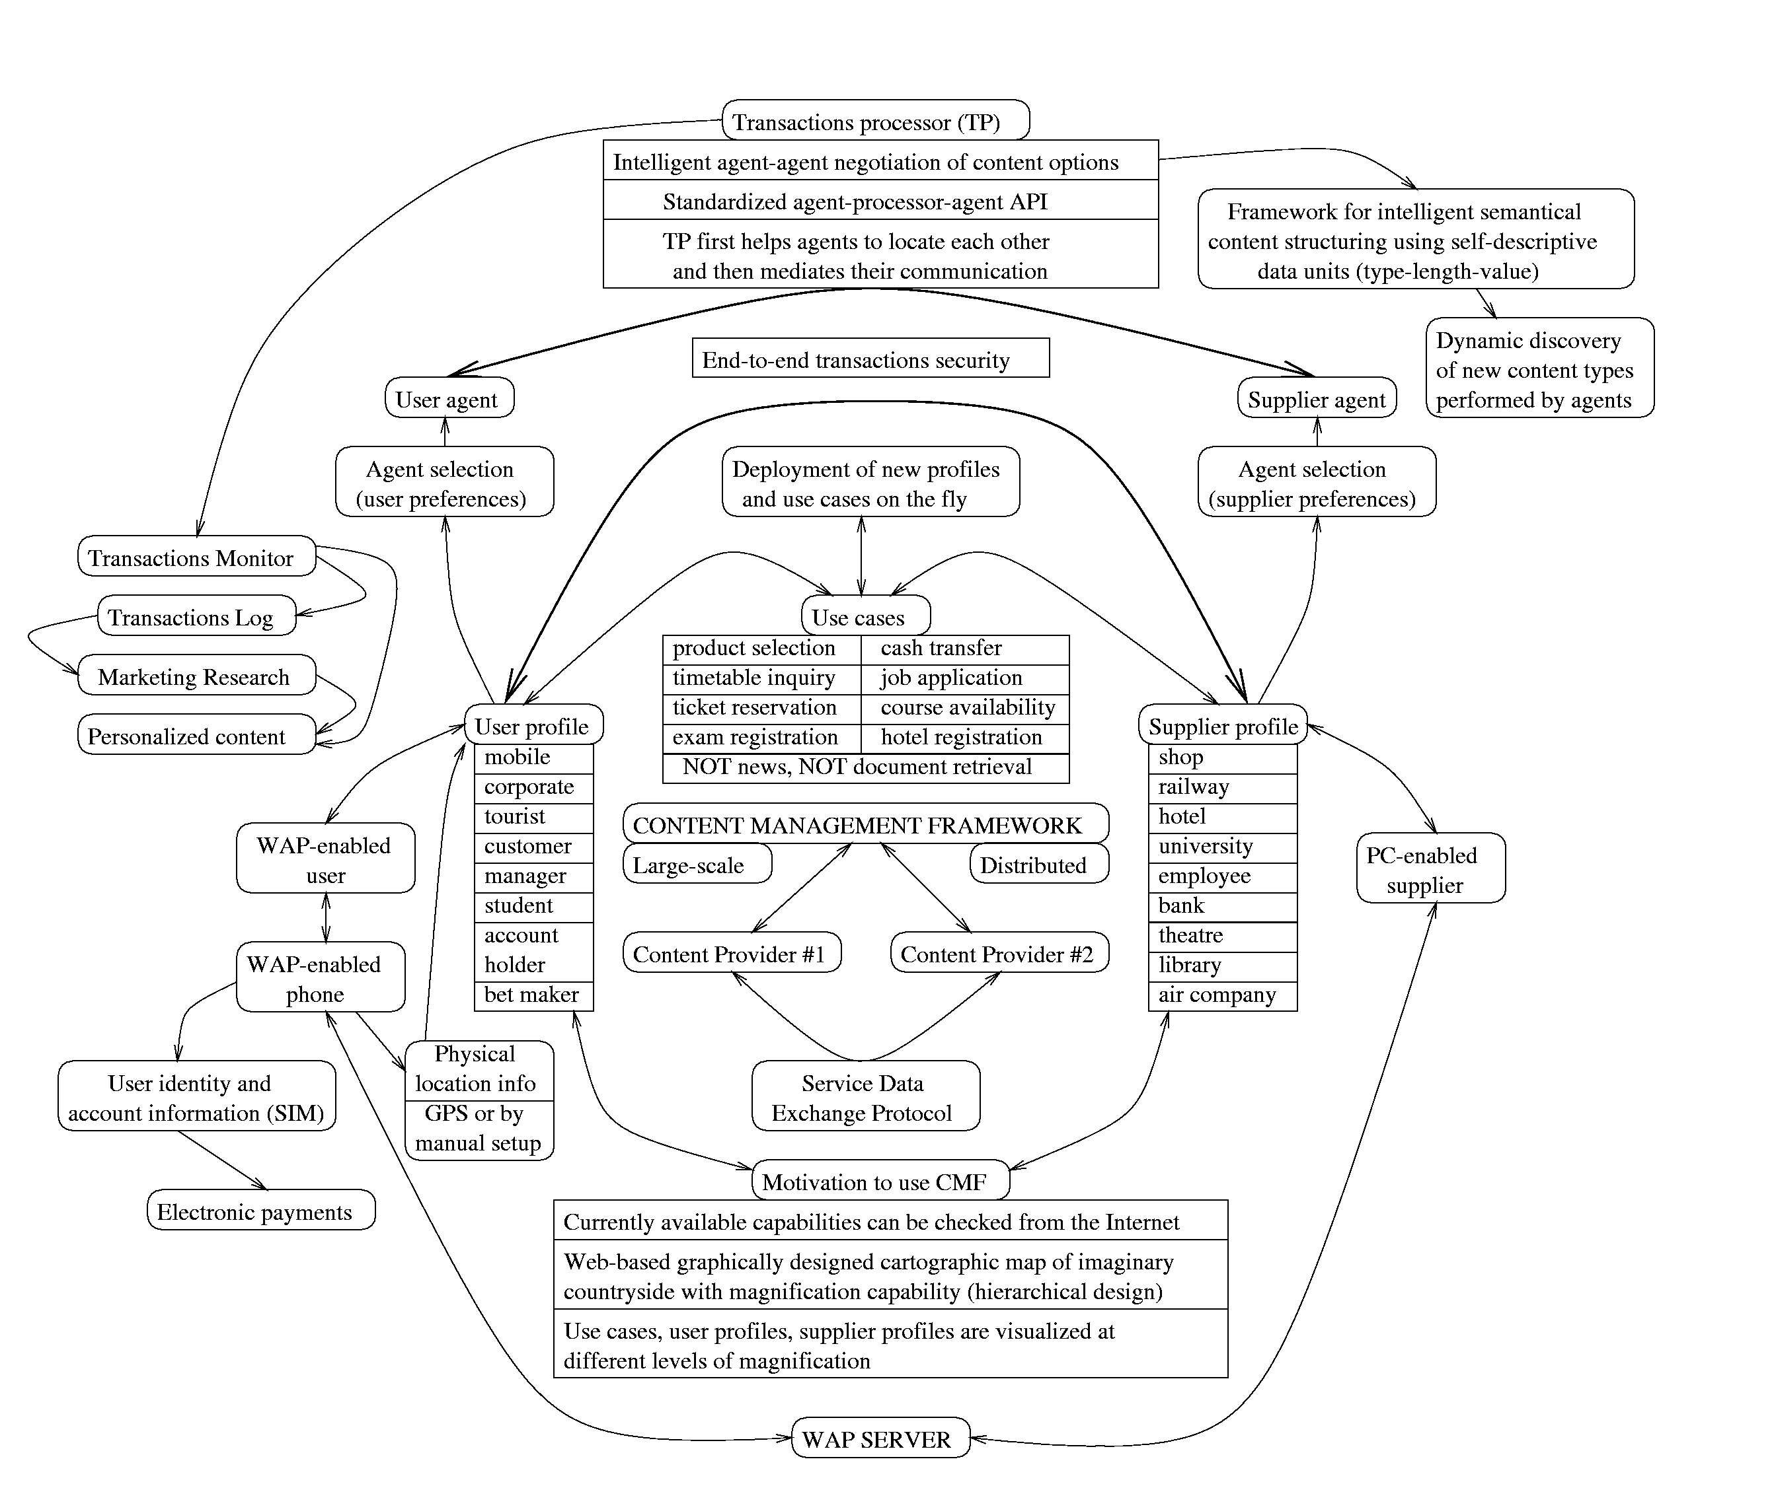
Figure 2. Content Management Framework Project Mind Map

4 Case Study: Hotel Reservation Use Case

Consider a use case when a nomadic user finds himself in a city he has never visited before ("tourist" user profile) and is willing to make an immediate hotel reservation using his WAP-enabled mobile phone ("hotel reservation" use case). At least the following issues are expected to be addressed by CMF:

1 - How the user makes reservation in the fastest and most intuitive way even without having a slightest knowlegde of the registration procedure gained beforehand.

2 - How the hotels ("hotel" supplier profile) regularly advertise relevant content with minimal effort and how CMF can motivate contribution of such advertisements.

3 - Shall the attributes of advertisements coming from the same domain (e.g. from "hotels") be standardized to promote fair evaluation of different offerings and if so, then to which extent, so that the concept of personalization is preserved.

4 - How the payment for accepting the advertised content is done securely; the idea behind is that user's WAP phone acts as his electronic passport and credit card at the same time, intoducing more responsibilities for the phone owner.

5 - How different kinds of users and suppliers could be integrated within a single generic framework, considering there might be thousands of different types of demands, services and use cases.

6 - How to organize the network of content providers (which act as intermediaries between users and suppliers) in the most natural way; in particular, how to enable free and secure flow of information in providers domain.

7 - How to consider political issues, e.g. it which way suppliers can be ensured that their advertisements are processed fairly during retrieval and selection procedure;

8 - Should there be any means for obtaining user positioning information (using either GPS or through manual user set-up) and if so, how this will affect the process of information retrieval upon user request.

9 - How to motivate the use of CMF by both parties, i.e. how to advertise CMF capabilities, especially as new capabilities evolve.

Note that the example above represents just a single use case, a business-oriented one. There may be plenty of other use cases with completely different properties, e.g. a "conference registration", what may impose more new requirements on CMF.

5 IPMAN CMF Project Stages

5.1 Project Strategy

It is evident that the scope of goals identified is ambitious at least, unmanageable at most. At the same time, it is desirable to achieve some practical results within limited time and budget. The idea is to have well-defined tasks for early stages of the project, keeping in mind that their results are expected to form the grounds for investigation of less defined tasks formulated for later stages.

We see the problem with some previous research efforts in that they concentrated on architectural issues before the expected functional background of a new archtecture has been explored sufficiently. In other words, before a new architecture is created, it is enormously important to have a very clear vision what its practical implications will be. This is especially true for service-oriented and content-oriented frameworks. Hence, we identify two well-defined tasks for now, leaving the third one for the future as more expertise is collected and more practical knowledge is gained:

Task (1): Use cases identification (which means derivation of practical scenarios from user, provider and supplier perspectives described in English-prose form).

Task (2): Black-box pre-prototype implementation of CMF: although the exact architecture of CMF is not known at this point, it would still be valuable to design a detailed visual demonstration of its capabilities. At this stage "black-box" means that the actual logic of CMF is not implemented, but operations of CMF are simulated and vizualized, using scenarios derived during the previous stage.

Task (3): Based on scenarios and pre-prototype implementation, the actual architechture of CMF is defined and its actual logic is implemented.

5.2 Identification of Use Cases

First, we identify different user profiles and then analyze what kind of personal content would be practically valuable for each profile, as well as what would be an attractive, intuitively appealing and concise form for accessing the personal content and in which way the content could be deployed and updated easily and dynamically (i.e. how heterogeneous content suppliers could be motivated to offer their services using CMF).

To reach this goal, at first stage we are primarily focused on deriving as many possible use cases, user profiles and supplier profiles as it would be practically achievable. Identifying use cases means that we are investigating concrete scenarios of actions taken by content users, suppliers and providers in which involvement of CMF is regarded as beneficial. The resulting document should contain concise English-prose description of each identified use case together with all relevant illustrative material attached. In addition, some use cases may be targeted at demonstrating technically innovative solutions expected to be used within the framework itself, such as agent technology, distribution of providers, user global positioning, user identity encapsulated within SIM card and so forth.

5.3. Pre-prototype black-box imlementation

At this stage, a black-box implementation of CMF prototype is produced. "Black-box" means that the internal structure of CMF is still not known in detail, but its external behaviour at this point is well-defined and undermined by use cases created during the previous stage. Based on identified use cases, a visual demonstration of CMF capabilities is developed. Instead of implementing the actual logic of CMF, its operations are simulated and vizualized using scenarios.

5.4. Prototype design and implementation

At this point, the detailed architecture of prototype is designed and at least part of it is implemented. The final prototype architecture is derived from analysis of results of pre-prototype implementation and from the initially designed high-level CMF architecture.

