Helsinki University of Technology
Espoo, Finland

Project: IPMAN

Task: Identification of Use Cases

Author: Voitto Terrihauta

Date: 21.7.2000

First, we identify different user profiles and then analyze what kind of personal content would be practically valuable for each profile. To reach this goal, at first stage we are primarily focused on deriving as many possible use cases, user profiles and supplier profiles as it would be practically achievable.

Identifying use cases means that we are investigating concrete scenarios of actions taken by content users, suppliers and providers in which involvement of CMF is regarded as beneficial. The resulting document should contain concise English-prose description of each identified use case together with all relevant illustrative material attached. Later on in use cases we focused on UML.

Generally use case is a typical interaction between a user and a computer system. But in this stage we focused on WAP users and services that are ordered by suppliers.

At first it is made different types of Use Cases. Some in Powerpoint, other xFigure drawing program in Linux. It is used site http://www.gelon.net/links. There are different categories of WAP services from business to travel. It helps us to understand what kind of services available today in WAP phones. There are 8 different use cases. Each case has it’s own purposes. For example in the fourth case, tourist tries to make a hotel reservation in Italian city. First he picks up city and it’s hotels. There are different kinds of hotels available. He selects a hotel. Each hotel has address and telephone number. The only thing which is left is to call hotel reception and his hotel reservation. This was ordered by BookOnLine Italy Hotel reservation.

In the first case it was selected travel category. CitiWiz (figure 1) produces this service. User selects the Content and then the city of Europe and America. After that he/she can choose hotels, restaurants and car rental. In some cities there are bar/clubs and shopping available. When tourist has chosen a hotel. He/she can look at the WAP phone how to get to hotel(bus, tram and underground)also a description of hotel and hotel has phone number and address.

In the second case (figure 2. M-emergency) we focused on London 999 Police travel helplines. WAP user can ask the police concerning fire/medic stuff. There are different kinds of helplines available (transport, Crisis ), Government directory and other Europe of city. Transport helplines consists of transport, Bus, Airports and Rail. The transport has bus and underground. And each has telephone number. Crisis helpline consists of crimestoppers and drugs. User can call these organizations if it is necessary. From the city of Europe user can select Athens or Berlin. They have ambulance, doctor, fire and police helplines. User can call their numbers if it is necessary.

Third case is dealing with business, which is provided by Advanced telecom (figure 3.Advanced telecom/business). This is a complete communication service provider. User selects WAP links. There are BBC news, Club Nokia, DHL, Newspaper Guardian, other news and E-Wap phone Fun. BBC consists of FastSearch, News, Sport and Weather service. E-Wap phone Fun consists of Jokes, Quiz, Horoscopes, Inspiration and Trivia. Sport link has Top Stories, Football EURO 2000, Tennis Wimpledon, Golf and Motosport F1. From Motosport link user can read the event of races and drivers.
Each of users can read his/her own horoscope from horoscope link.

In fifth case Wap – user selects sport and from there Atp.tour.com (figure 5. Sport/Atptour.com). First you have to click Menu order to get other links. Now press OK. After that user can select Information site where is information of Atp.tour. On the other hand user can select Live version or the news from games. And user can see ATP standings. By pressing “back” button user can choose different languages.

Sixth case is dealing with finance and it is ordered by 123Jump.com (figure 6. Finance/123Jump.com). This service provider gives user information of quotes, news, markets, portfolio, financial glossary. From the news link user finds Tickers and keywords. Markets show user indicators what is most active today. From Most Active link user can select Nasdaq Active, Nasdaq Gainers and Losers. Some of these have Ticker, change and what is last situation on the market.

The 7th use case is dealing with Portal and is provided by iTouch mPortal / New Zeeland ( figure 7. Portal/iTouch mPortal). Perhaps this service is meant to the people from New Zeeland.. There are different services available from NZ herald to iHelp. NZ herald orders Soccer news to the users. From NZ entertainment user can search TV programs or film festival. Major City weather service order user weather report around New Zeeland. In this case iLinks has different services from Wap country lists to Vodafone NZ.

Perhaps the most important thing which is available on Wap phones thinking TriMedia services is Rishworth school. This use case called Rishworth school, service provider, helps students find daily program from Wap phones. This calendar consist of weekly program. There are also Suggestions and Contact links available. There are email, telephone number and fax on the phone. User can find given address and also Webmasters email and Web-pages.

1.Use Case / travel /ZitiWiz

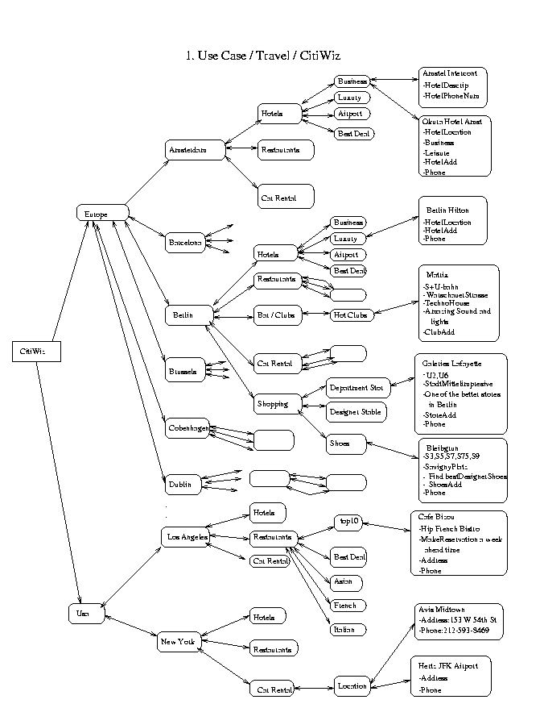
Figure 1. Travel / CitiWiz

Figure 1. Travel / ZitiWiz
2.Use Case /travel/m-emergency

Figure2. Travel / m-emergency

3.Use Case / business /Adv_telecom

Figure 3. Business / Advanced telecom
4.Use case / travel / Hotel reservation

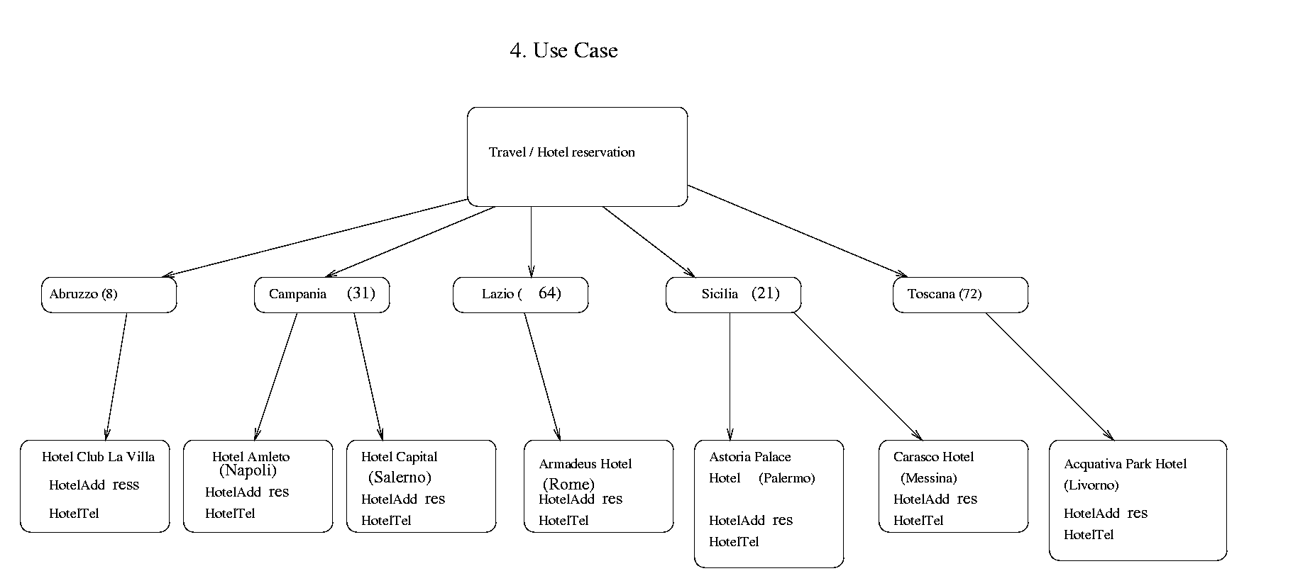

Figure 4. Travel / Hotel reservation

5.Use Case / sport /atptour.com

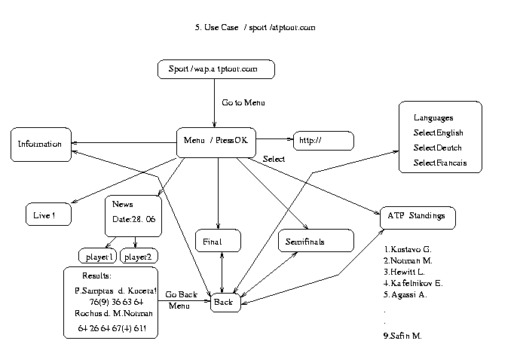
Figure 5. Sport / Atptour.com
6.Use Case / Finance /123Jump.com

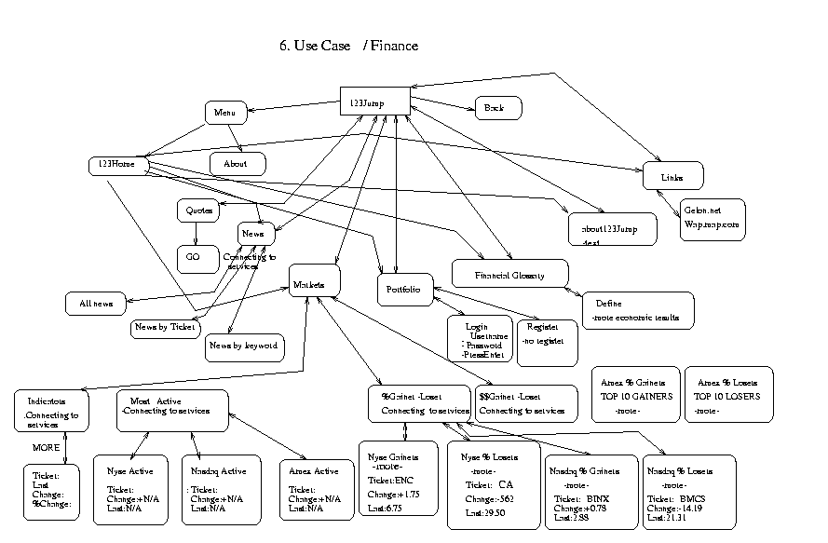
Figure 6. Finance / 123Jump.com

7. Use Case / Portal /iTouch mPortal

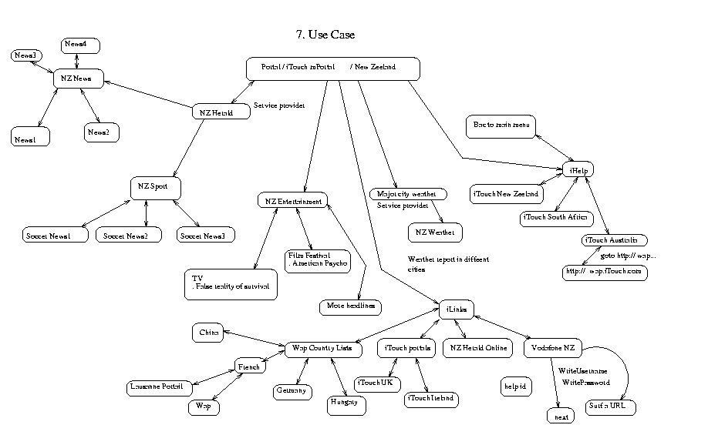
Figure 7. Portal/iTouch mPortal/NZ
8.Use Case / Education /Rishworth school

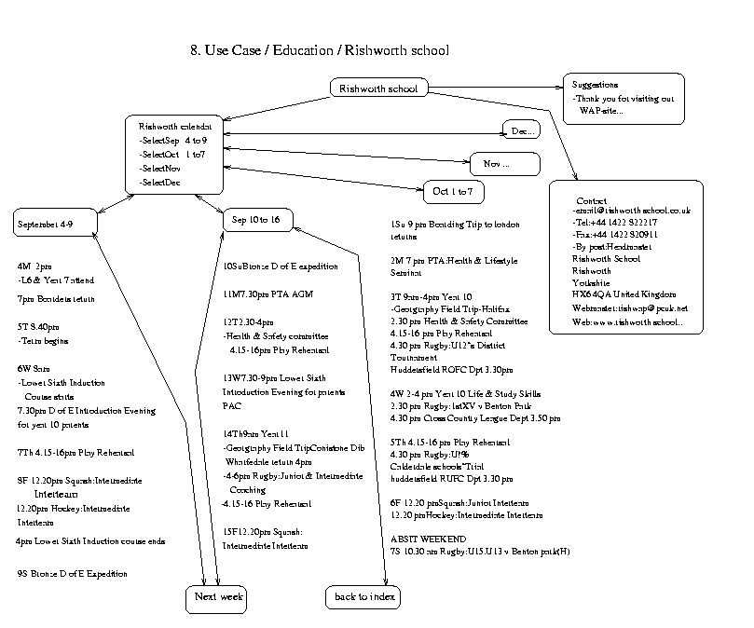
Figure 8. Education / Rishworth school

